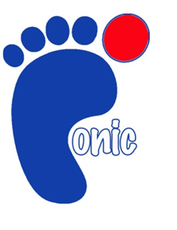

**Need assistance cutting**

**Your toenails?**

**NHS trained staff**

**Cut from comfort of your own home**

**£11 cutting fee**

**Friendly reliable service**

**Basildon Community Transport Services**

The George Hurd Centre Audley Way, Basildon SS14 2FL

**For more information please call 01268 294 325**

**17**

**£12 Annual membership fee**

**£20 returnable deposit**

**6 week hire period**

**Small or large wheeled wheelchairs available**

Wheelchair Hire Available

**Registered Charity No: 1146853**

**For more information please call 01268 294 334**

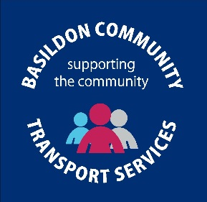

**Are you elderly, disabled or cannot access public transport?**

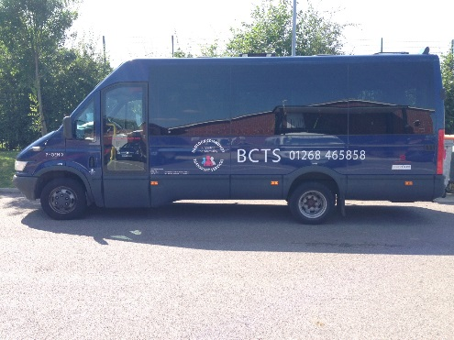

**£12 Annual membership plus a low cost mileage charge**

**NOW ACCEPTING VALID BUS PASSES ON MINIBUSES**

**Providing transport to medical appointments, day centres, social visits, shopping and many more ….**

**We are here to help you with your transport needs!**

**Registered Charity No: 1146853**

**We are a low cost door to door service**

* **We have a fleet of wheelchair accessible minibuses**
* **Cars available driven by our volunteer car drivers**
* **All drivers have valid Enhanced DBS**

**Volunteer Car Drivers Wanted!**

**We are looking to recruit volunteer car drivers to help provide our essential service to the residents of the borough.**

**For information Please call 01268 465 858**